**INTRODUCTION**

I create a Reservation system for a Hotel. It is a simple system that has no transaction. This system allows you to show the 2 tables which is the Guest table which allows you to show the list of guest, contact number, address, guest number and the Reservation number. At the table 2, at the Reservation table, you can show the check in date, check out date, room, Room type and also the Reservation number. This system is easy to understand.

**OBJECTIVES**

* Create a database for the organization.
* To show the Details of the 2 tables
* To show the Primary Keys
* To show How to operate the system
* To show SQL commands.

# Table Description

|  |  |  |  |  |  |
| --- | --- | --- | --- | --- | --- |
| **Table Name** | **Purpose of table** | **Column’s Name** | **Column’s Purpose** | **Column’s Data Type and With** | **Column’s Attribute** |
| **Guest** | To show the information about the Guest | Reservation_  Number | To show the Res  .number  of the Guest | number | **Primary key** |
|  |  | name | contains Guest  name | Varchar, 15 | Null |
|  |  | Address | contains Guest Address | Varchar,  15 | Null |
|  |  | Contact Number | Contains Contact  number | Number,  15 | null |
|  |  | Guest Number | Contains Guest number | Number | null |
| **Reservations** | Contains  The details of reservations | Reservation number | Contains the Reservation number of the Guest | Number | **Primary Key** |
|  |  | Room type | Type of room | Varchar | null |
|  |  | Room | Type of room bldg.. | Varchar,  15 | null |
|  |  | Check out date | Date of check out | Varchar | Null |
|  |  | Check in date | Date of check in | Varchar | null |

# Script Listing

**Creating a Table for Guest**

..On the SQL application, type:

create table Guest

(Name varchar2(13),

Contact_Number number(11),

Address varchar2(30),

Guest_Number number(3),

Reservation_number number(3));

And a table will be created!

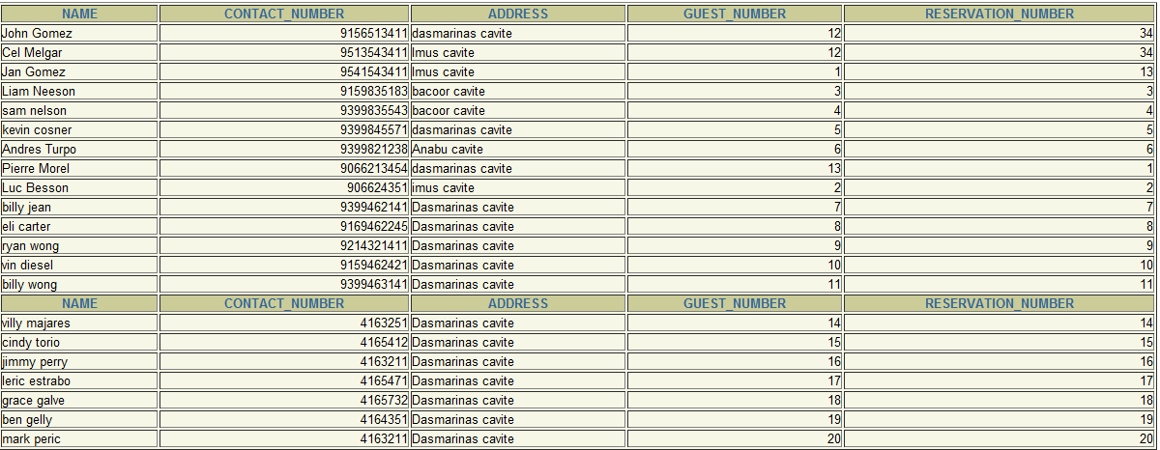

**Creating a Table for Reservations**

..On the SQL application, type:

create table Reservations

(Check_in_date varchar2(13),

Check_out_date varchar(13),

Room varchar2(30),

Room_type varchar(30),

Reservation_number number(3));

And a table will be Created!

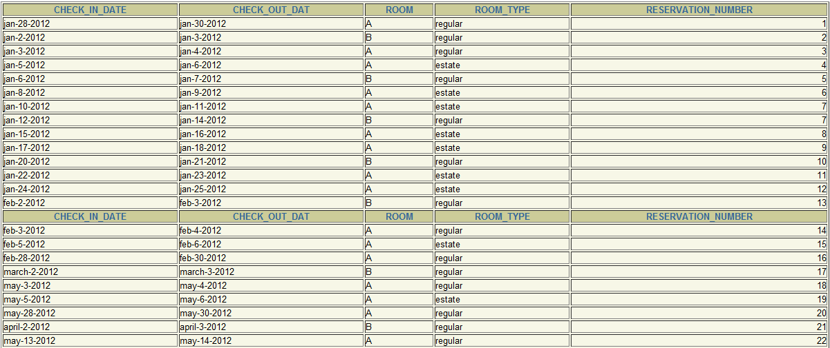

**INSERTING DATA FIELDS INTO TABLE1 (GUEST)**

Now, to insert information on the table..

insert into guest(name,contact_number,address,guest_number,reservation_number)

values('karel honasan',09541614531,'Tagaytay',14,3)

insert into guest(name,contact_number,address,guest_number,reservation_number)

values('michael lopez',09541543531,'dasma cavite',13,23)

insert into guest(name,contact_number,address,guest_number,reservation_number)

values('Jan Gomez',09541543411,'Imus cavite',1,13)

insert into guest(name,contact_number,address,guest_number,reservation_number)

values('Cel Melgar',09513543411,'Imus cavite',12,34)

insert into guest(name,contact_number,address,guest_number,reservation_number)

values('Jan Gomez',09541543411,'Imus cavite',1,13)

insert into guest(name,contact_number,address,guest_number,reservation_number)

values('Andres Turpo',09399821238,'Anabu cavite',6,6)

insert into guest(name,contact_number,address,guest_number,reservation_number)

values('kevin cosner',09399845571,'dasmarinas cavite',5,5)

insert into guest(name,contact_number,address,guest_number,reservation_number)

values('sam nelson',09399835543,'bacoor cavite',4,4)

insert into guest(name,contact_number,address,guest_number,reservation_number)

values('Liam Neeson',09159835183,'bacoor cavite',3,3)

insert into guest(name,contact_number,address,guest_number,reservation_number)

values('Luc Besson',0906624351,'imus cavite',2,2)

insert into guest(name,contact_number,address,guest_number,reservation_number)

values('Pierre Morel',09066213454,'dasmarinas cavite',13,1)

insert into guest(name,contact_number,address,guest_number,reservation_number)

values('billy jean',09399462141,'Dasmarinas cavite',7,7);

insert into guest(name,contact_number,address,guest_number,reservation_number)

values('eli carter',09169462245,'Dasmarinas cavite',8,8);

insert into guest(name,contact_number,address,guest_number,reservation_number)

values('ryan wong',09214321411,'Dasmarinas cavite',9,9);

insert into guest(name,contact_number,address,guest_number,reservation_number)

values('vin diesel',09159462421,'Dasmarinas cavite',10,10);

insert into guest(name,contact_number,address,guest_number,reservation_number)

values('billy wong',09399463141,'Dasmarinas cavite',11,11);

insert into guest(name,contact_number,address,guest_number,reservation_number)

values('villy majares',4163251,'Dasmarinas cavite',14,14);

insert into guest(name,contact_number,address,guest_number,reservation_number)

values('cindy torio',4165412,'Dasmarinas cavite',15,15);

insert into guest(name,contact_number,address,guest_number,reservation_number)

values('jimmy perry',4163211,'Dasmarinas cavite',16,16);

insert into guest(name,contact_number,address,guest_number,reservation_number)

values('leric estrabo',4165471,'Dasmarinas cavite',17,17);

insert into guest(name,contact_number,address,guest_number,reservation_number)

values('grace galve',4165732,'Dasmarinas cavite',18,18);

insert into guest(name,contact_number,address,guest_number,reservation_number)

values('ben gelly',4164351,'Dasmarinas cavite',19,19);

insert into guest(name,contact_number,address,guest_number,reservation_number)

values('mark peric',4163211,'Dasmarinas cavite',20,20);

This is an example of inserting a data on a table.

**CREATING TABLE FOR RESERVATIONS DEPARTMENT**

Another table creation for Reservations station.

create table Reservations

(Check_in_date varchar2(13),

Check_out_date varchar(13),

Room varchar2(30),

Room_type varchar(30),

Reservation_number number(3));

**INSERTING DATA FIELDS INTO TABLE2 (RESERVATIONS)**

insert into Reservations(Check_in_date ,Check_out_date,Room,Room_type,Reservation_number)

values('jan-12-2012','jan-14-2012','B','regular',7);

insert into Reservations(Check_in_date ,Check_out_date,Room,Room_type,Reservation_number)

values('jan-15-2012','jan-16-2012','A','estate',8);

insert into Reservations(Check_in_date ,Check_out_date,Room,Room_type,Reservation_number)

values('jan-17-2012','jan-18-2012','A','estate',9);

insert into Reservations(Check_in_date ,Check_out_date,Room,Room_type,Reservation_number)

values('jan-20-2012','jan-21-2012','B','regular',10);

insert into Reservations(Check_in_date ,Check_out_date,Room,Room_type,Reservation_number)

values('jan-22-2012','jan-23-2012','A','estate',11);

insert into Reservations(Check_in_date ,Check_out_date,Room,Room_type,Reservation_number)

values('jan-24-2012','jan-25-2012','A','estate',12);

insert into Reservations(Check_in_date ,Check_out_date,Room,Room_type,Reservation_number)

values('jan-6-2012','jan-7-2012','B','regular',5);

insert into Reservations(Check_in_date ,Check_out_date,Room,Room_type,Reservation_number)

values('jan-8-2012','jan-9-2012','A','estate',6);

insert into Reservations(Check_in_date ,Check_out_date,Room,Room_type,Reservation_number)

values('jan-10-2012','jan-11-2012','A','estate',7);

insert into Reservations(Check_in_date ,Check_out_date,Room,Room_type,Reservation_number)

values('jan-2-2012','jan-3-2012','B','regular',2);

insert into Reservations(Check_in_date ,Check_out_date,Room,Room_type,Reservation_number)

values('jan-3-2012','jan-4-2012','A','regular',3);

insert into Reservations(Check_in_date ,Check_out_date,Room,Room_type,Reservation_number)

values('jan-5-2012','jan-6-2012','A','estate',4);

insert into Reservations(Check_in_date ,Check_out_date,Room,Room_type,Reservation_number)

values('jan-28-2012','jan-30-2012','A','regular',1);

insert into Reservations(Check_in_date ,Check_out_date,Room,Room_type,Reservation_number)

values('april-2-2012','april-3-2012','B','regular',21);

insert into Reservations(Check_in_date ,Check_out_date,Room,Room_type,Reservation_number)

values('may-13-2012','may-14-2012','A','regular',22);

insert into Reservations(Check_in_date ,Check_out_date,Room,Room_type,Reservation_number)

values('march-2-2012','march-3-2012','B','regular',17);

insert into Reservations(Check_in_date ,Check_out_date,Room,Room_type,Reservation_number)

values('may-3-2012','may-4-2012','A','regular',18);

insert into Reservations(Check_in_date ,Check_out_date,Room,Room_type,Reservation_number)

values('may-5-2012','may-6-2012','A','estate',19);

insert into Reservations(Check_in_date ,Check_out_date,Room,Room_type,Reservation_number)

values('may-28-2012','may-30-2012','A','regular',20);

insert into Reservations(Check_in_date ,Check_out_date,Room,Room_type,Reservation_number)

values('feb-2-2012','feb-3-2012','B','regular',13);

insert into Reservations(Check_in_date ,Check_out_date,Room,Room_type,Reservation_number)

values('feb-3-2012','feb-4-2012','A','regular',14);

insert into Reservations(Check_in_date ,Check_out_date,Room,Room_type,Reservation_number)

values('feb-5-2012','feb-6-2012','A','estate',15);

insert into Reservations(Check_in_date ,Check_out_date,Room,Room_type,Reservation_number)

values('feb-28-2012','feb-30-2012','A','regular',16);

1. **Program testing**

|  |  |
| --- | --- |
| **Test Case** | **Objectives** |
| 1 | To check the ability for creating a table for employee informations |
| 2 | To check the ability for creating table for Reservations. |
| 3 | To check the ability for inserting data on each table |
| 4 | To update a value in a record |
| 5 | To delete a record |

**Test Cases and Results**

Test Case : 1

Objective : To check the ability for creating a table for guest informations.

Test Data : name, contact number, address and Reservation_number

Expected Test Result : One table for student information must be created.

Test case: 2

Objective : To check the ability for creating a table for Reservations.

Test Data : check in date, check out date, hiredate, room

Expected Test Result : One table for Reservations must be created.

Test Case : 3

Objective : To check the ability for inserting data on each table

Test Data : 1, null

Expected Test Result : One row must be created on each table.

Test Case : 4

Objective: To update a value in a record.

Test data: UPDATE Guest Set nam=’Sai’ where Reservation_number=1;

Result: Success!

Test Case: 5

Objective: To Delete a Record.

Test Data: Delete from Guest where Reservation_number = 1 or name = ‘Sai’;

Result: Success!

**Conclusion:**

I therefore conclude that learning sql is not very easy at it looks

But learning sql is fun.

# User Manual

Before using this system, you have to open your Internet browser. After you open your internet browser, type the address which is ‘192.168.1.215/isqlplus(take note that this address depends at your server which the server has set it. For short, it is Permanent.).

After typing the exact address, there is a Log in which you have to type the username and password. Just type at the log in screen; the Username is **Project**, and the Password is **admin**. And you are ready to go.

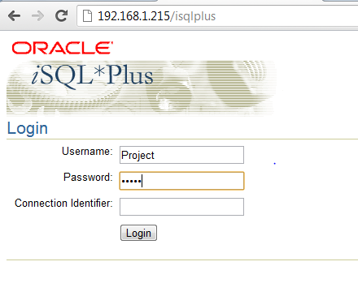

After you log in here is the Step by Step on using the code:

1. Create a table.
2. If there’s no any record of a details of reservation then paste the code for inserting a reservation details on the table.
3. For updating use the proper update code for table.

Note : User can easily use the code because there is proper labeling at the top of each operation.

1. **SQL COMMANDS**

**SELECTING GUEST TABLE**

Type “select * from GUEST;”



**SELECTING RESERVATIONS TABLE**

select * from RESERVATIONS;



**Restriction and Projection**

**With Where Clause:**

SELECT NAME, CONTACT_NUMBER, ADDRESS, GUEST_NUMBER, RESERVATION_NUMBER

FROM Guest

WHERE RESERVATION_NUMBER=13 ;



**Alias**

select Reservation_number as Reserved from Guest;

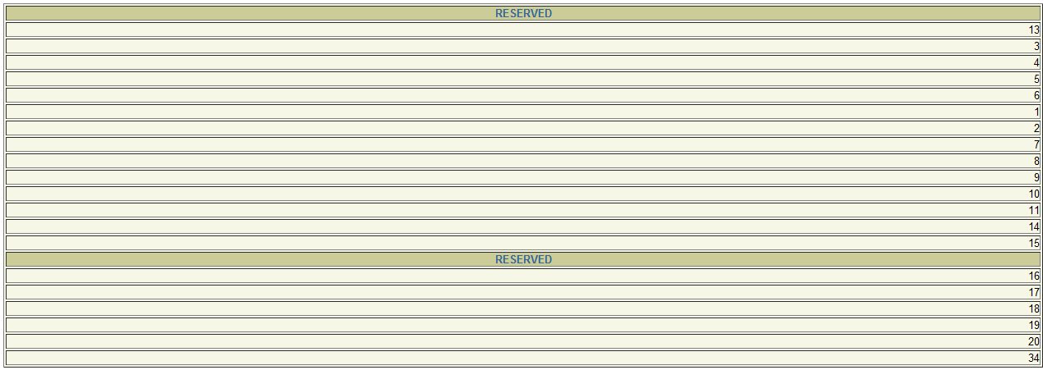

**Concatenation**

select concat(name,address) from guest;

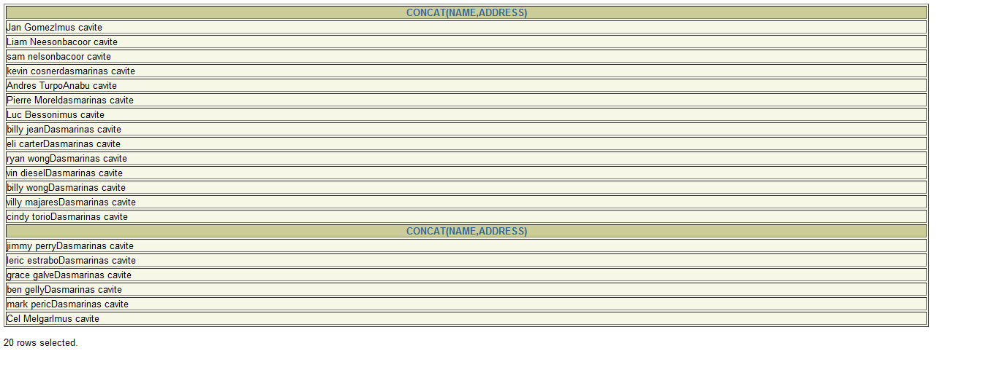

**Comparison Operator**

select * from GUEST where RESERVATION_NUMBER=13;



**Logical Operator**

select * from guest where guest_number=1 and Reservation_number=13;



**Sorting**

**Ascending:**

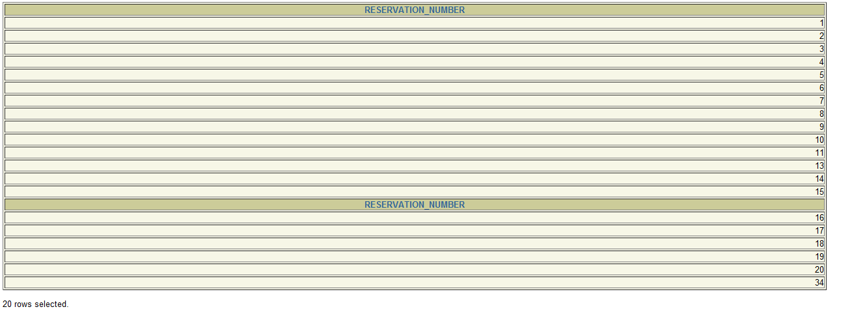

Select Reservation_number from guest order by Reservation_number asc;

**Descending:**

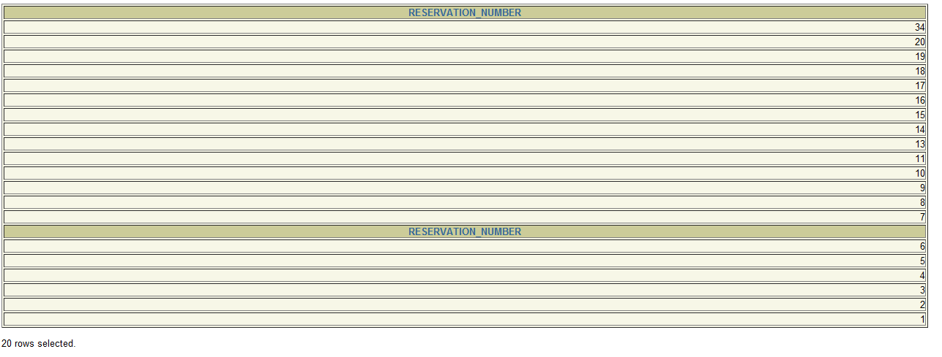

Select Reservation_number from guest order by Reservation_number desc;

**Joins:**

Natural join:

select check_in_date, Check_out_date, room, room_type, Reservation_number

from guest

natural join Reservations;

